**Community Profile of Census Tract 4403.08**

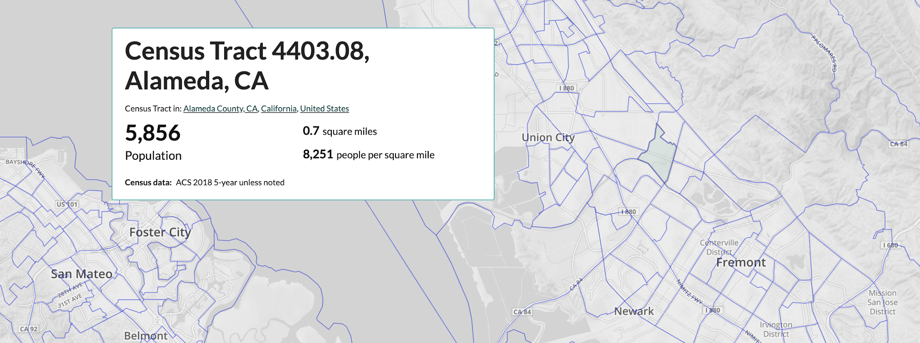

**Prepared for the Union City Planning Department**

**Howon Kim and Frank Juan**

**Department of City and Regional Planning**

**University of Berkeley, California**

**Jun 2020**

Introduction

**Union City and Tract 4403.8**

Union City is located in the south of Silicon Valley, covering an area of 19 square miles. In terms of the educational environment, it has two community colleges, seven primary schools, two junior high schools, and a high school. In terms of the economic environment, Union City has three large health care providers and a 100-acre shopping center, which has provided many local employment opportunities. In terms of population composition, the largest ethnic group in Union City is Asians, followed by Hispanics and whites, while blacks only account for 5 percent. More specific data is expanded below. The community profile is Tract 4403.8 and it is the main research area of the portfolio. It is located in the city center of Union City, covering an area of 0.71 square miles. The specific data will also be developed later. (In this portfolio, the words area/location is referred to as Tract 4403.8.)

Population and Household

Variables and Finding

The data we are focusing on this portfolio is the population/household structure, racial/ethnic composition, income and poverty levels, and labor force characteristics. Our main goal is to explore the impact of income changes on different ethnic groups.

Population and People

The total population of this area has decreased from 6422 in 2010 to 5856 in 2018, which decreased 8.8%, average of 1% per year . The population of this area accounted for 9.43% of the total population of Union City in 2010, and decreased to 7.85% in 2018. In 2015 and 2016, there was a significant return of population, this situation has also happened in the entire Union City. The decrease in the population is related to the decrease in household number and average household size and rising cost of living. We will have more discussion in the part of Household Structure.

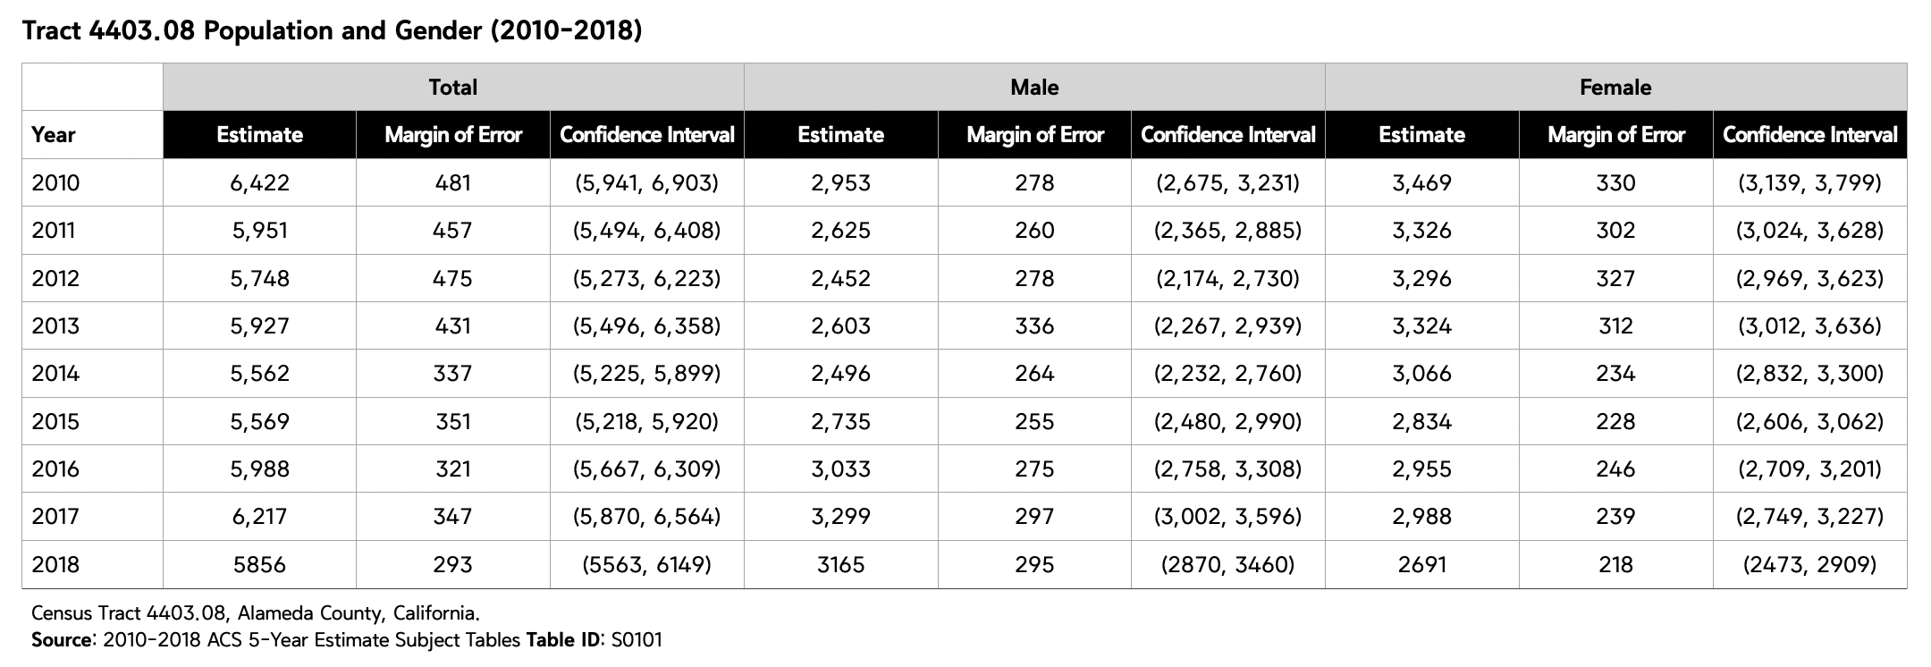

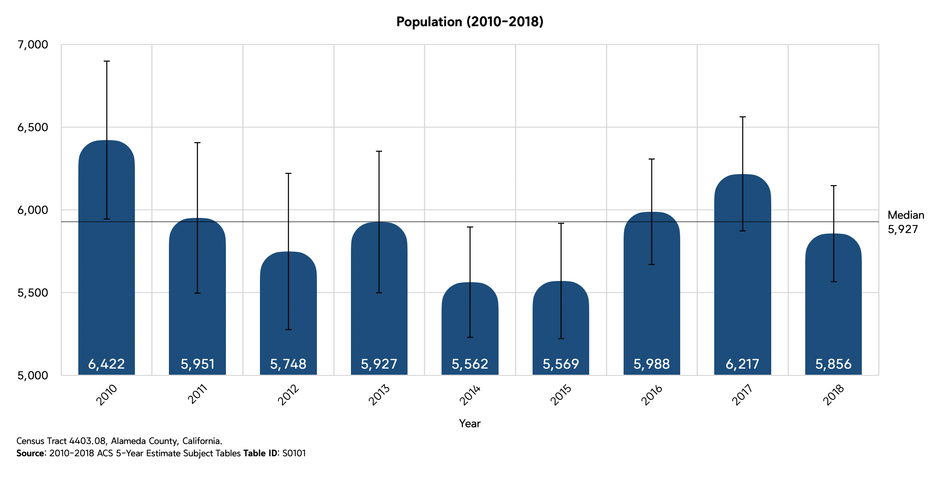

**Age Structure and Gender Mix**

In 2010, the ratio of men to women was close to 4:6, and this gap continued to increase in the next three years. The first decrease in the proportion of women occurred in 2013. In 2016, the number of men surpassed the number of women, and in 2018, the number of men was 3165, and the number of women was 2691.

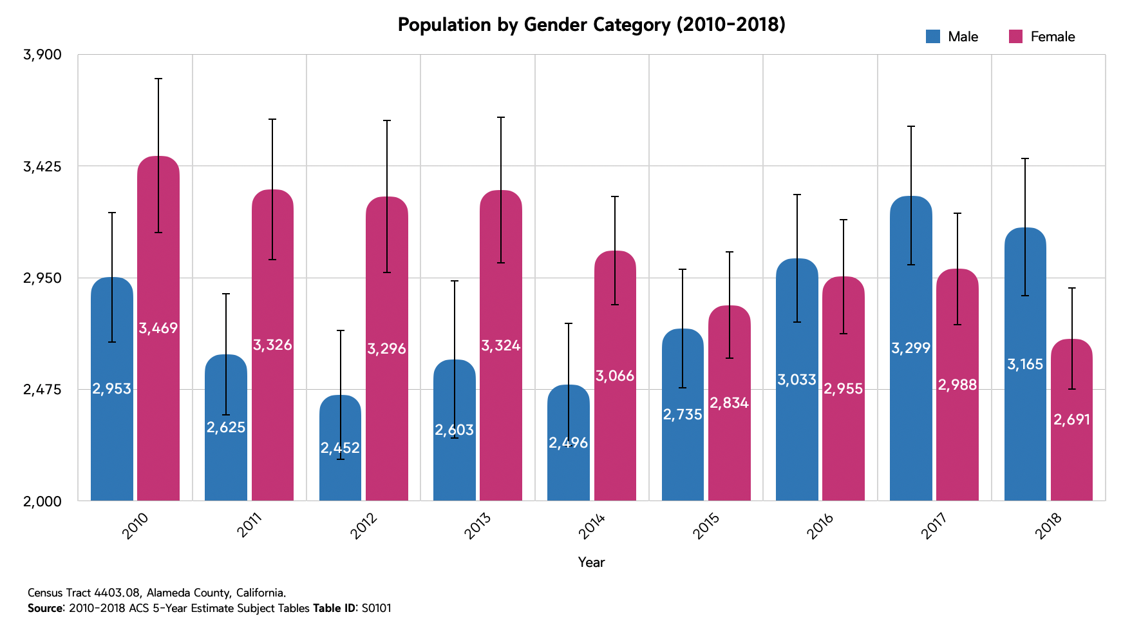

Age structure

From 2010 to 2018, Students (10-24) have decreased, Working age group (25-44) has increased, and the 65-74 age group has increased (not significant). The change in the number of teenagers and working groups may be due to changes in family structure. We will have more discussion in the part of Family Structures.

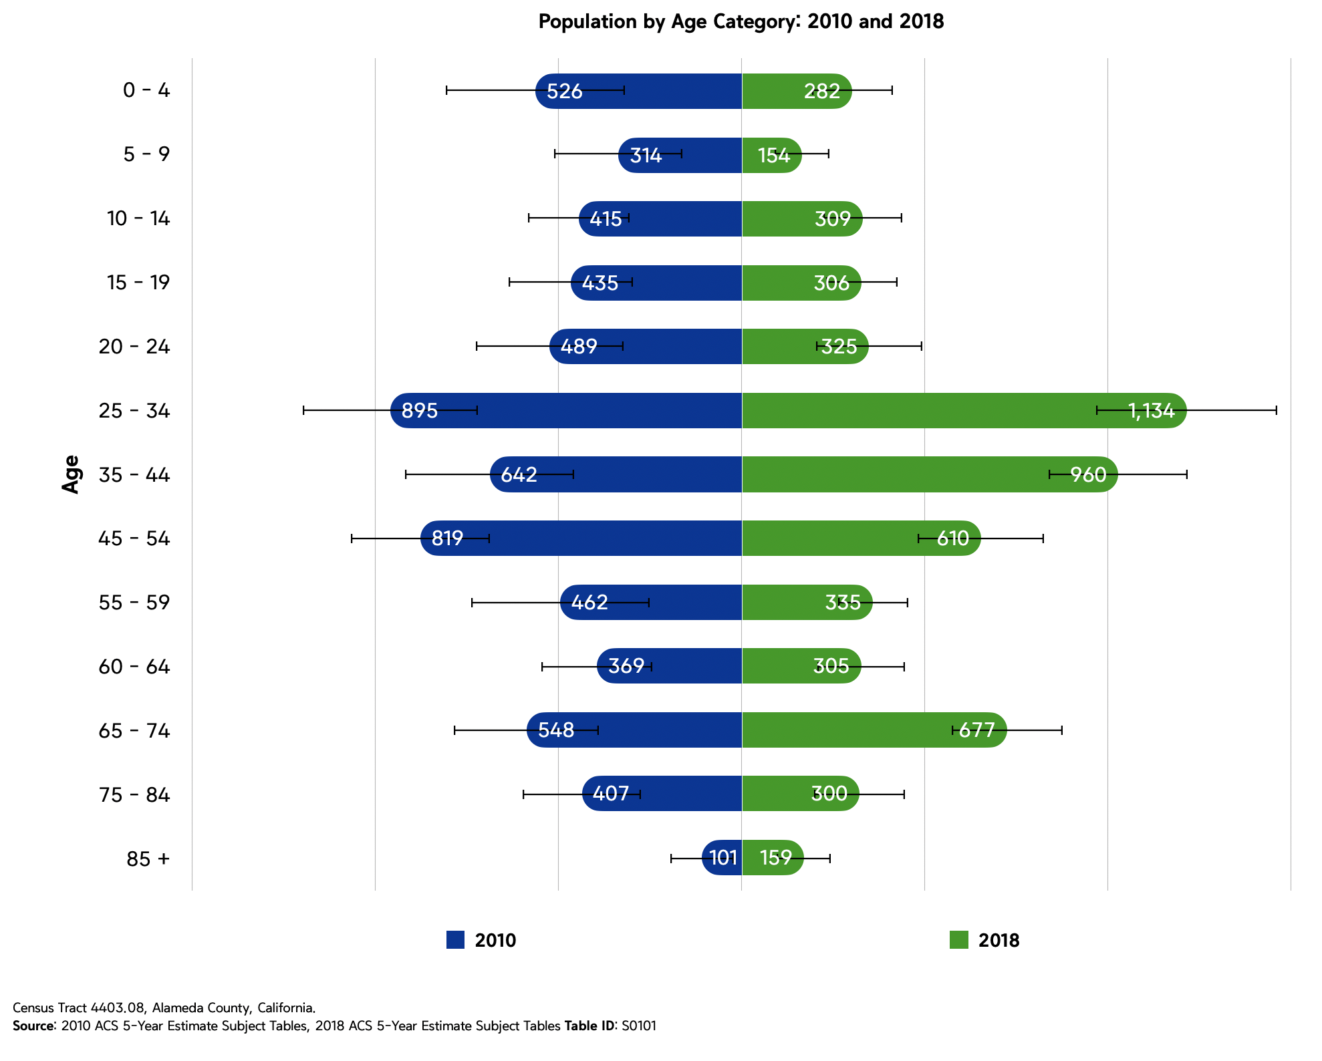

**Racial and Ethnic composition**

The population of this area is mainly Asians, followed by Whites and other races. Black people are a minority here, accounting for less than 5%. From 2010 to 2018, the proportion of Hispanic has decreased from 31.8% to 27.3%, and the population of Asia has dropped from 3200 to 3136, but the proportion of the population has increased from 49.8% to 53.6%. <Wrong Number>

If we compare the ethnic structure of this area and the entire Union City, we can find that there is not much difference between the two. The reason for this population structure may be related to the working environment of Silicon Valley, we will discuss more in the Part of Labor force characteristic.

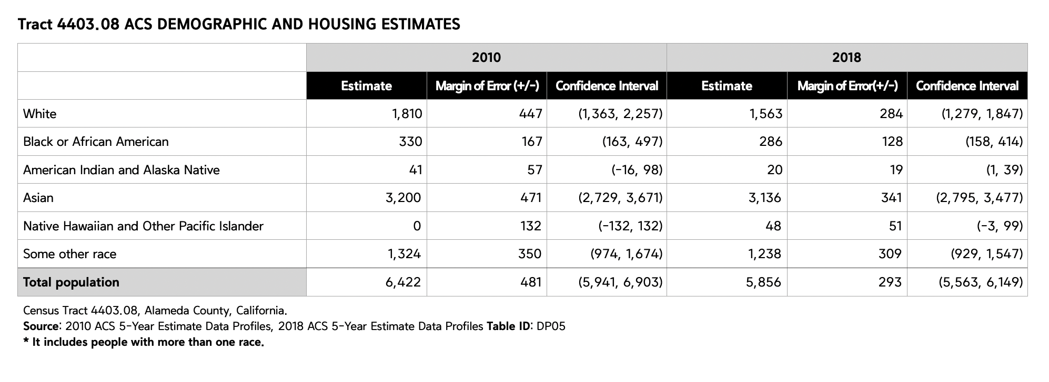

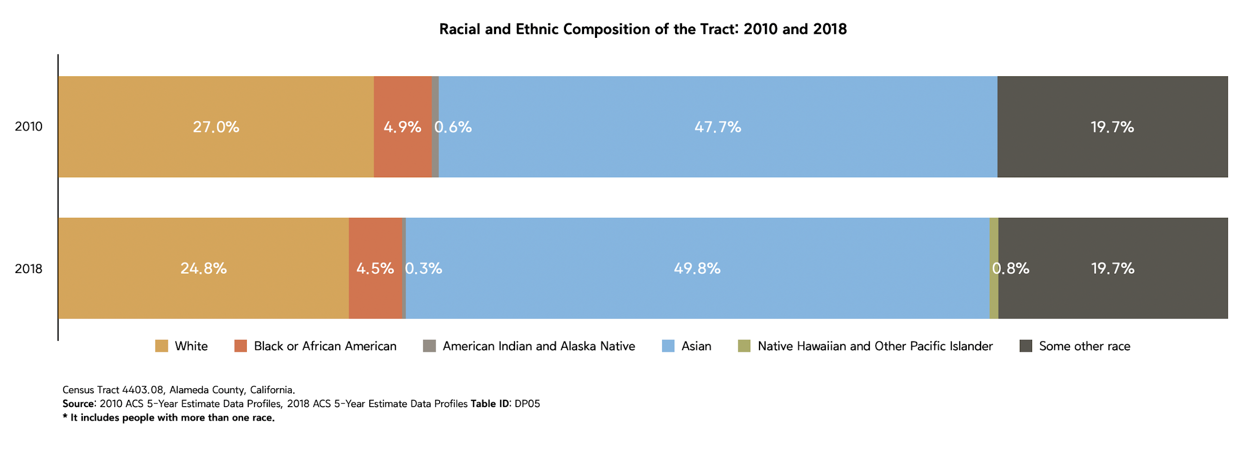

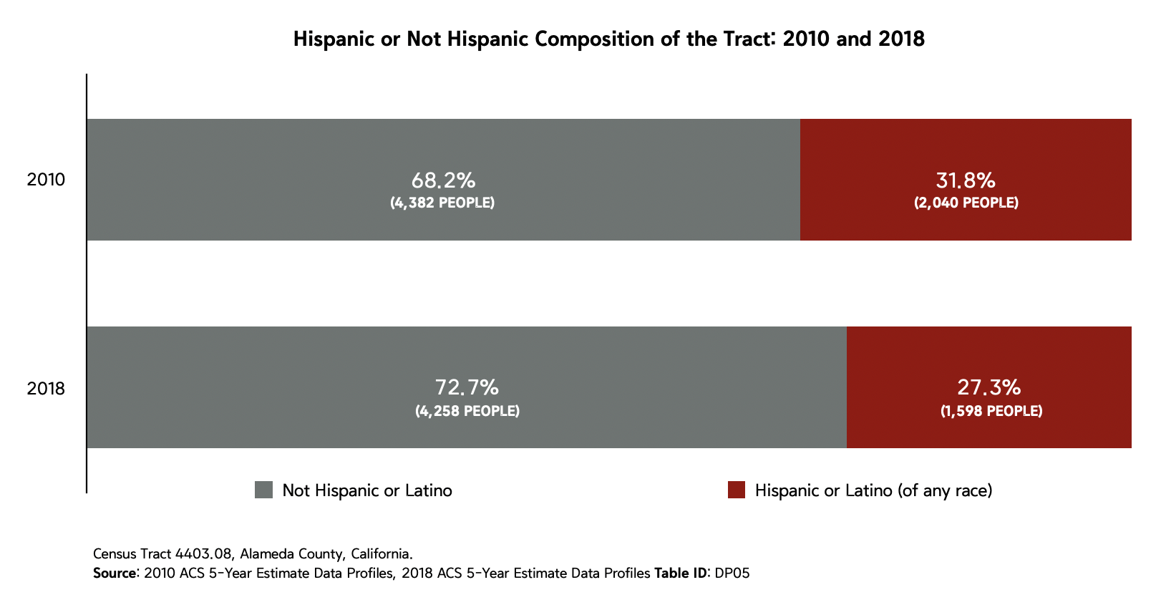

**// NEWLY ADD // - HISPANIC COMPOSITION COMPARE WITH UNION CITY IN 2018**

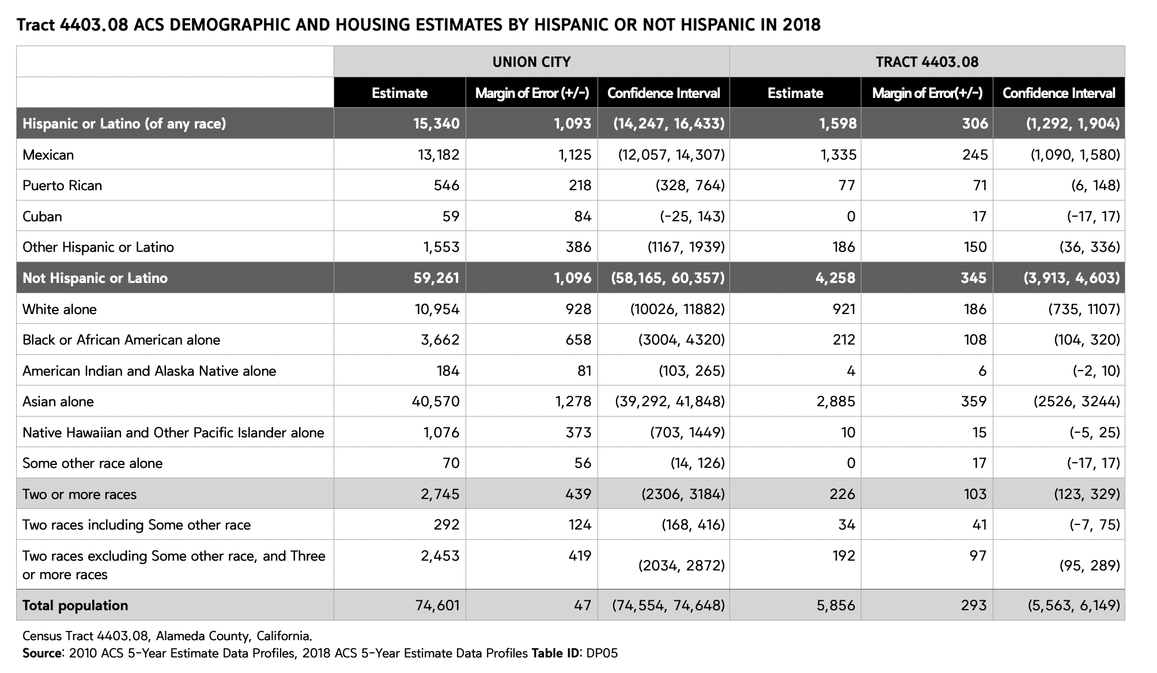

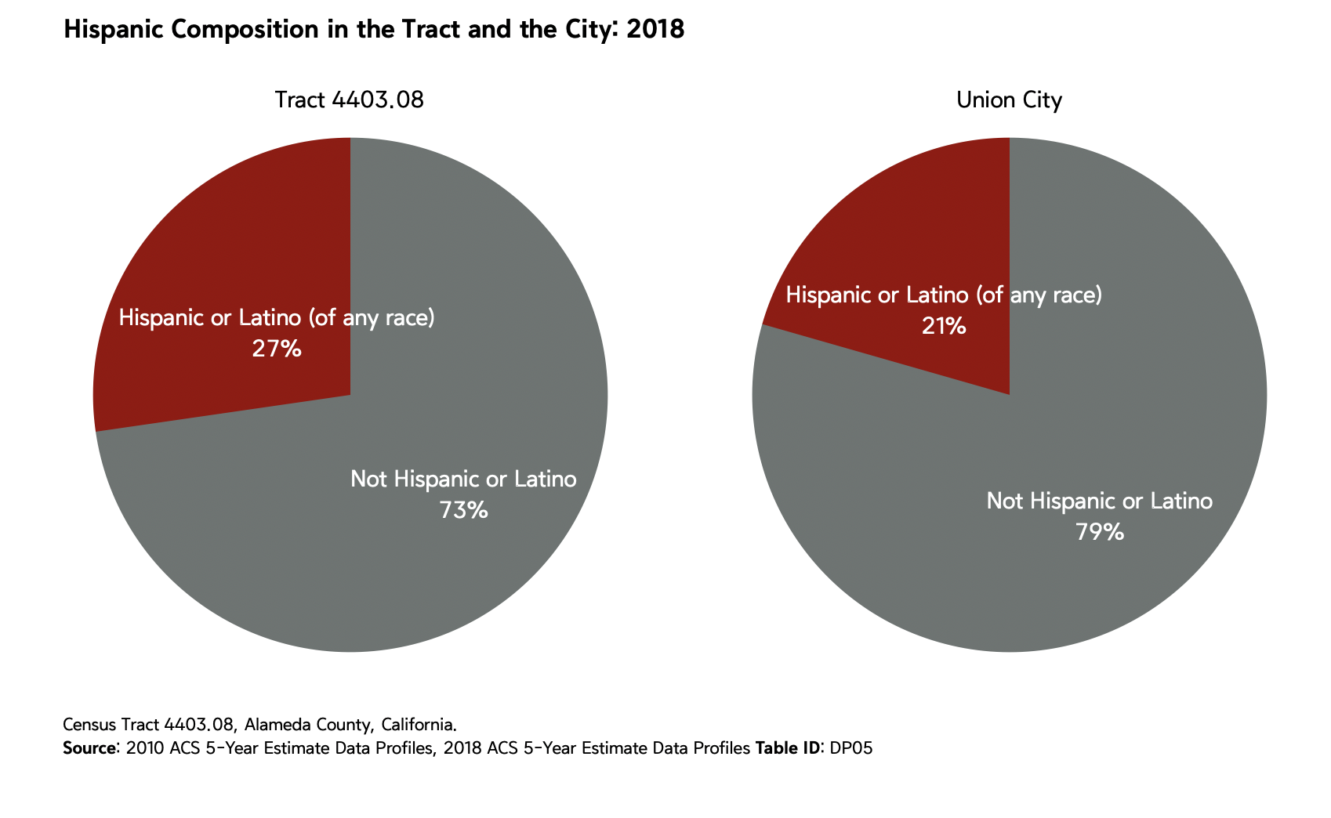

**Household structure, income, and poverty level.**

The correlation between population and household number is 0.877, and 0.922 for the population size. From 2010 to 2018, the household number has decreased from 1981 to 1943, and household average size has decreased from 3.24 to 2.93.

Household Structure!!!

The proportion of households with one or more under 18 years old has decreased from 43.6% to 33.2%, the median of the rent has increased from $1098 to $2042, the proportion of household income below 25,000 has decreased from 23.8% to 11.2%, the number of the married-couple family household has decreased from 1,334 to 1156, nonfamily household has increased from 340 to 520, and there were 1005 households moved into this area, and 1043 moved away.

The changes in the structure of the household in this area mainly come from the departure of the married household and the move-in of the nonfamily household. This situation has led to a reduction in average household size from 3.24 to 2.93. At the same time, the departure of married households has also caused a sharp decrease in the proportion of teenagers in this area. On the other hand, in 2010, 88% of the male with no wife householder had at least one teenager in their family, but in 2018, the percentage sharply decreased to 10.6%. In 2010, more than 30% of adults didn't have a job. And from 2010 to 2018, rents of housing in the area nearly doubled, which may be the reason for some households have to move away from this area. This has further reduced the proportion of poor people.

**D-7 Income and Poverty Level**

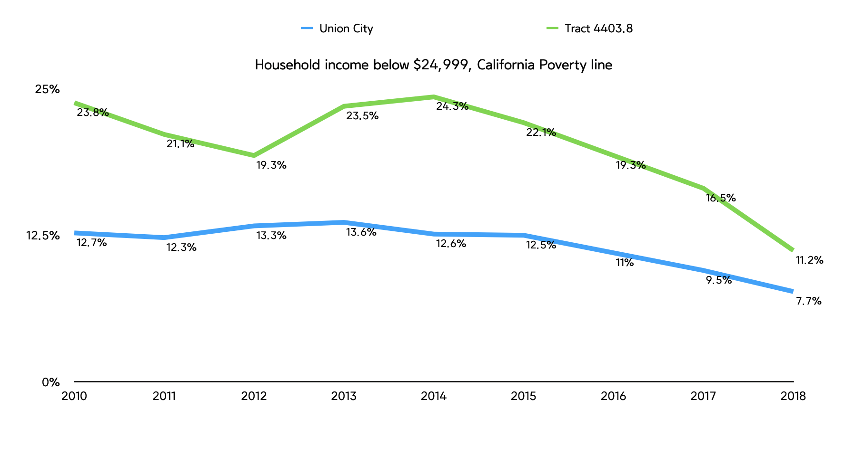

The poverty household ratio in 2018 was half of that in 2010. The reason for the decline in the poverty household ratio was due to the increase in the employment rate and average wages. Compared with the $86,144 in 2010, the average annual household income in 2018 was $119,877, and the proportion of households with incomes above 200,000 was three times higher than in 2010. The change in the family’s annual income is related to the population movement we mentioned in "Population and Household"; low-income people leave and high-income people move into the city. Base on the graph above, we can see that the poverty household ratio of this area was getting closer to the poverty household ratio of the entire city. For different jobs that affect income, we will discuss more in “Labor force characteristic”.

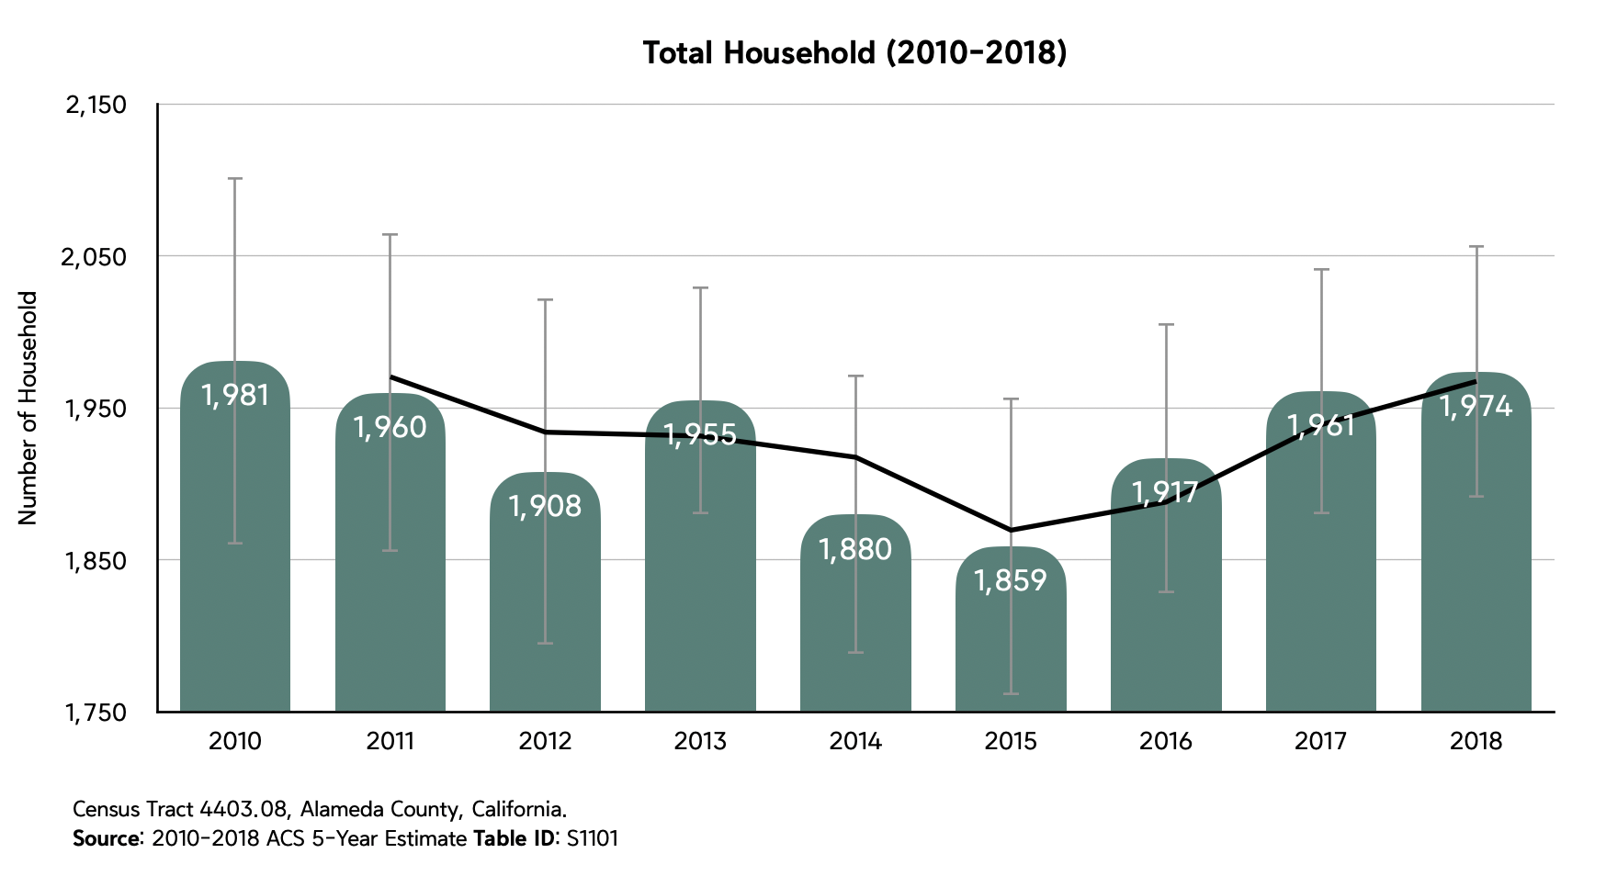

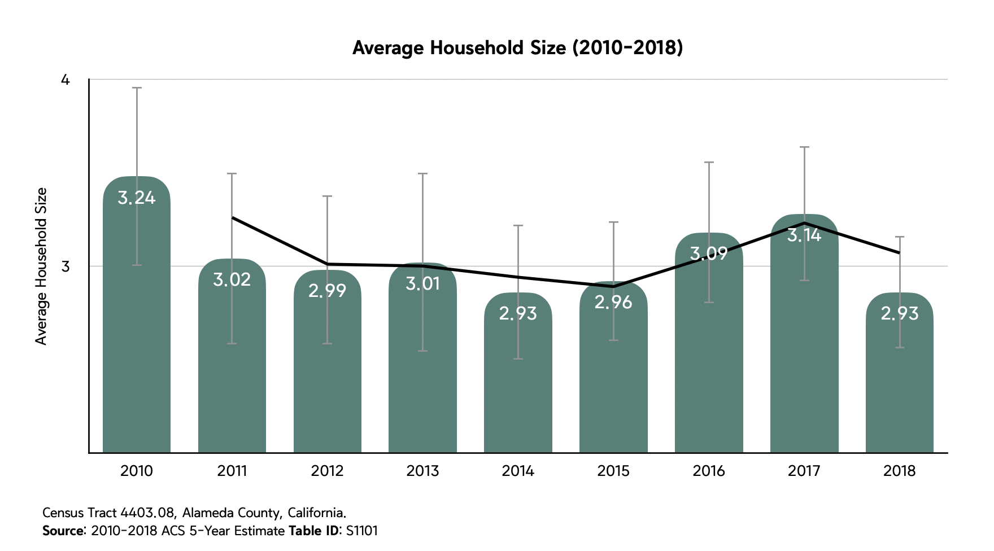

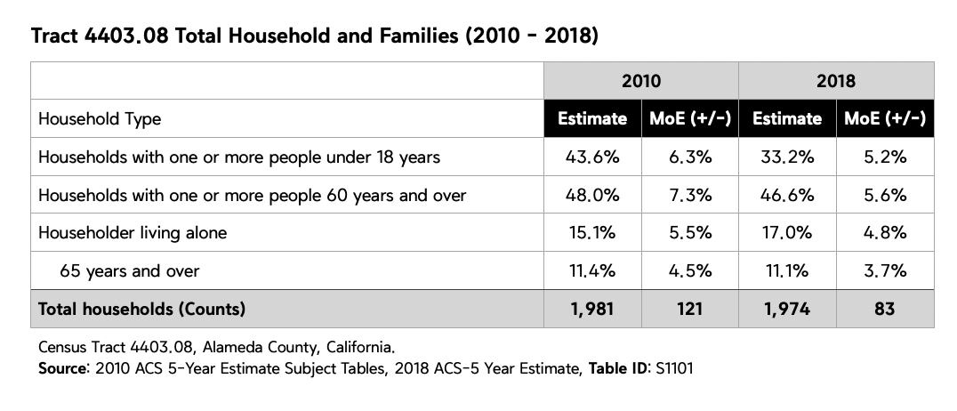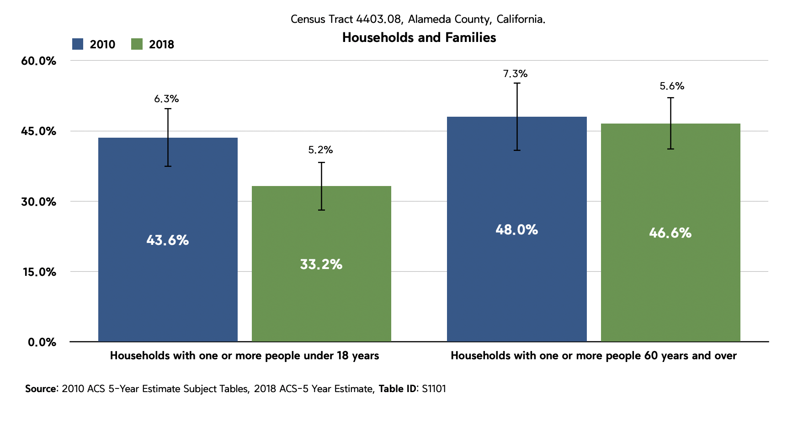

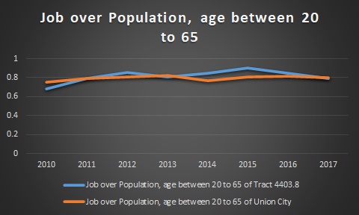

labor force characteristics

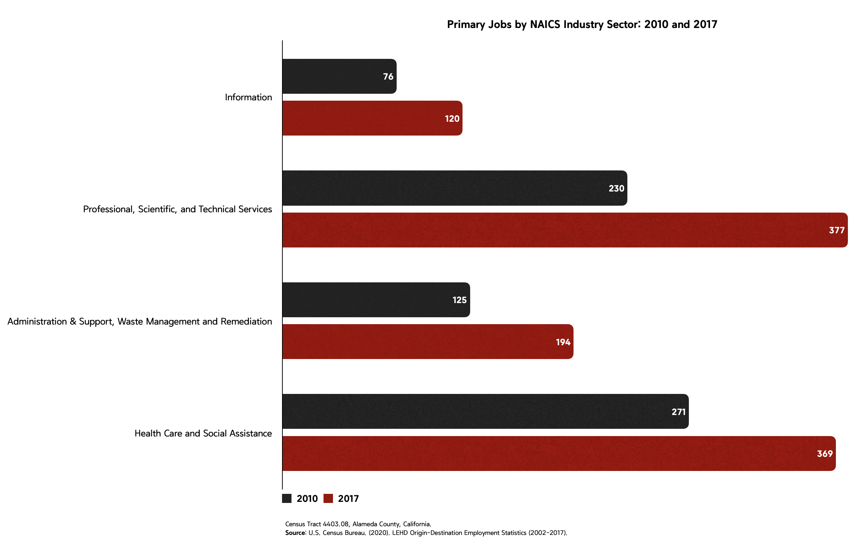

The correlation between total job and the job with more than $3,333 wage per month is 0.8935. From 2010 to 2017, Job over population, age between 20 to 65, has increased from 68.5% to 79.1%, the number of total jobs has increased from 2,519 to 3,025, and the job number of “Professional, Scientific, and Technical Services” and “Health Care and Social Assistance” has increased from 529 to 820.

The number of lows- and middle-income jobs has remained almost unchanged in the past few years, but the number of high-income people has highly increased. Based on the development of the local medical industry and the Silicon Valley economy, this has led to an increase in the proportion of local people engaged in the jobs of “Professional, Scientific, and Technical Services”, “Health Care and Social Assistance”, and “Information”. Since this area is the center of Union City, the rise in the population of the entire Union City also increased the number of people engaged in the jobs of “Administration & Support, Waste Management and Remediation”. The number of other occupations has not changed much.

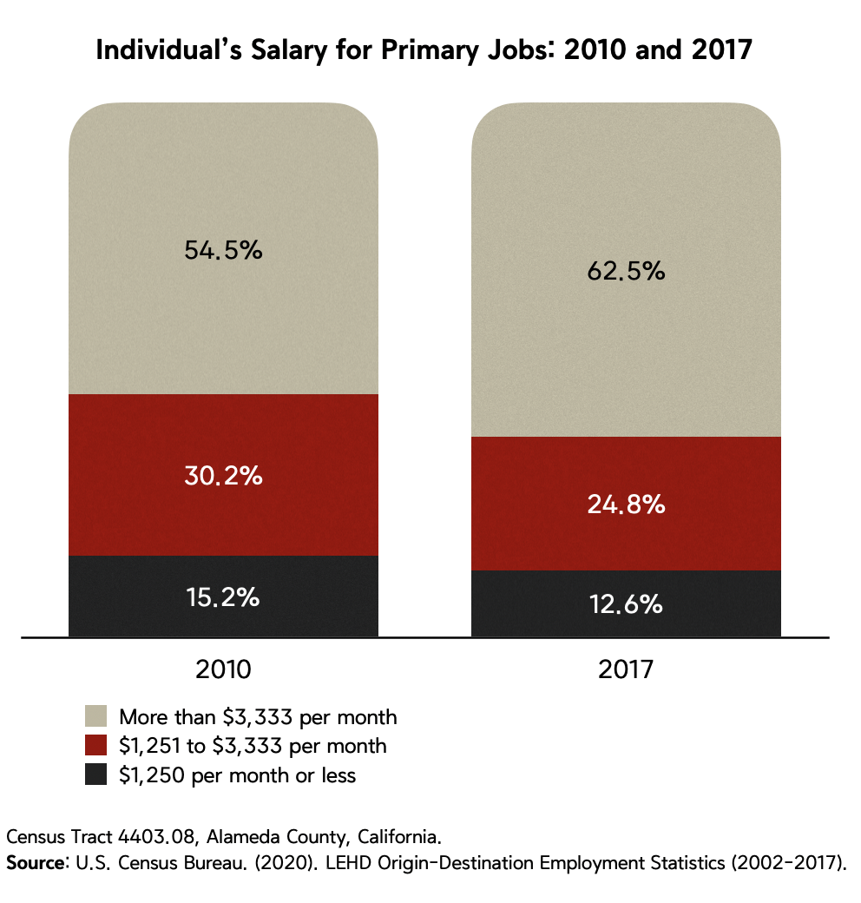

With the development of Silicon Valley, the employment opportunities in Silicon Valley have attracted many foreign talents. But as the population grew, this also led to rising prices and rents in Silicon Valley and nearby areas. From 2010 to 2018, rents in this area have Roughly doubled, and there were 1005 households moved into this area, and 1043 households moved away. Among these people who moved away, most of them were women, teenagers, blacks, Hispanics, and low-income households. The demographic change may have accelerated the economic development of this area, but it also forced those who lived here to leave, and this will have a great impact on them. Take teenagers as an example, whether they can get the same education and living environment after moving is a question worth studying. Such a problem does not only occur in this area, but also in the entire Union City. When we learn from the data that certain ethnic groups will be sacrificed because of economic development, we also need to reflect on whether we need to bear such a price.

The demographic changes in this region also show that the demographic structure is no longer diverse, and the continuous increase in the number of Asians can illustrate this point. The growth of the Asian population is mainly related to the working environment in Silicon Valley and the habits of Asians. The demand for electronics professionals in the Silicon Valley area has attracted a lot of Asians, and they have gathered together to be able to accompany each other. This situation also makes Asians the majority of this area, and the proportion of other ethnic groups continues to decrease.